Quantitative screening of bioactive phytochemicals in wastes of banana plants.
Reham M.Mostafa *, Aly A.A **,Hazaa M.M* and Heba S.Essawy * .
Botany Department Faculty of Science , Benha University, Egypt. *
**Chemistry Department Faculty of Science , Benha University, Egypt.
Abstract
Pseudostem waste of banana plants shows the pharmacological activities and help to explore the medicinal value for the initiation of further extensive research on other possible biological activities. As well as for the development of new generic drugs for the better treatment of uncontrolled diseases. .This work presents the investigation of Phytochemical screening on extracts of pseudostem wastes of banana cvs. Baradika , Maghrabi , senari and Williams. This screening shows the presence of alkaloid, tannin, steroid, terpene, saponin and flavonoid in all banana cultivars. The variability of banana cultivars extracts in weight and colour due to the difference between them in phytochemical contents. The compound were fractionated and isolated from pseudostem wastes of banana. The purity as well as the unsaturated nature of the separated compound which gave positive reaction with characteristic test of Alkaloid with melting point 60° c. The structures of the isolated compounds was established by micro analysis , IR and Mass spectrometrium analysis. According to this analysis the molecular formula of structures C13H17NO6.
Key words; pseudostem wastes, banana cultivars, Phytochemical, alkaloid, micro analysis.
Introduction
Bananas and plantains, constitute the fourth most important global food commodity (after rice, wheat and maize) grown in more than 100 tropical and subtropical countries over a harvested area of approximately 10 million hectares, with an annual production of 88 million tones Frison and Sharrock, (1999).
Musa species, commonly known as banana, is one of the valuable plant species having a number of pharmacological activities .All parts of the plant including fruits, stem, leaves and flowers are used for its nutritional as well as therapeutic effect.
Both Musa paradisiaca and Musa sapientum are traditionally used in diarrhoea, dysentery, intestinal lesions in ulcerative colitis, diabetes, sprue, uremia, nephritis, gout, hypertension and cardiac disease. As well as the other parts of the plant are used to treat different diseases in human in traditional medicine Imam and Saleha (2011).
Musa species wastes consisted of different quantitative and qualitative bioactive phytochemical compounds like alkaloids. Medicinal plants are the richest bio-resource of drugs of traditional systems of medicine, modern medicines, nutraceuticals, food supplements, folk medicines, pharmaceutical intermediates and chemical entities for synthetic drugs. Extraction methods used pharmaceutically involves the separation of medicinally active portions of plant tissues from the inactive/inert components by using selective solvents. During extraction, solvents diffuse into the solid plant material and solubilize compounds with similar polarity Ncube et al., (2008) and phytochemical bioactive analysis of banana pseudostem cv. Maghrabi in Egypt showed the presence of reducing sugars, terpenoid ,flavonoids , saponins, tannins , alkaloids , steroids and anthrauinones. Dina et al., (2014).
The various solvents that are used in the extraction procedures. Water is universal solvent, used to extract plant products with antimicrobial activity. Acetone extract dissolves many hydrophilic and lipophilic components from the plants. Though traditional healers use primarily water but plant extracts from organic solvents have been found to give more consistent antimicrobial activity compared to water extract Das et al., (2010).
Alkaloids often contain one or more rings of carbon atoms, usually with a nitrogen atom in the ring. Many have declared pharmacological activity Harbone, (1998). Alkaloids have diverse structures and many show a range of pharmacological activities including antimicrobial activity Ahmed et al., (1986).
A wide range of biological effects has been reported for alkaloids, including emetic, anti-cholinergic, antitumor, diuretic, antiviral, and antihypertensive, hypo-analgesic, antidepressant, relaxant, anti-tussigen, antimicrobial and anti-inflammatory activities Henriques et al., (2004) and Aiello et al., (2011).
This study aims to analysis of phytochemical constituents of banana wastes by qualitative and quantitative to help explore the medicinal value of these wastes.
Materials and Methods
All experimental facilities and laboratory analysis were performed in Botany dep. Fac.of Sci. Benha Univ. And Chemistry & Microbiology dep. Fac.of Sci. & Res.Park, Fac. of Agri. Cairo Univ.
Plant materials
Pseudostem and leaves of Banana; Musa sapientum cvs. (Maghrabi and Williams) and Musa paradisiaca cvs. (Baradika and Senari) were collected from Benha belong to Qualubiya governorate. The plants were taxonomically identified and authenticated by the dep. of Botany, Fac. of Sci. Benha Univ . The plant material was air dried at room temperature until the dried material was stable. The dried waste material were ground into fine powder and transferred into air tight containers to protect them from humidity and light with proper labeling for future use.
Perparation of plant extract for qualitative analysis:
Crude plant extract was prepared by Soxhlet extraction method. 5gm of powdered plant material of each cultivar was uniformly packed into a thimble and extracted with 150ml of different solvents successively (Diethyl ether, petroleum ether (60-80), Chloroform, Benzene, Acetone and Ethanol 99%) Each time before employing the solvent of higher polarity was dried. Each extract was then concentrated using rotary vacuum evaporator at 40-50°C under vacuum and dried residue was collected in an opaque glass bottles for further studies.
Detection of phytochemical compounds:-
Phytochemical screening (Terpenoids, flavonoids, saponins, tannins, alkaloids) were performed using standard Procedures according to (Sofowora, 1993) as following.

Terpenoids: The Banana extract was added to chloroform with 5:2 (w/ v) and form layer. Concentrated H2SO4 (3ml) was carefully added to form a layer. A reddish brown colouration of the interface indicates the presence of terpenoids.
Flavonoids: A few drops of 1% aluminum solution were added to a portion of the extract. A yellow colouration indicates the presence of flavonoids.
Saponins: The banana extract was socked to distilled water with 0. 5: 5(w / v) in a test tube. The solution was shaken vigorously and observed for a stable persistent froth. The frothing was mixed with 3 drops of olive oil and shaken vigorously after which it was observed for the formation of an emulsion.
Tannins: The banana extract was boiled in distilled water with 0. 5: 10(w/ v) in a test tube and then filtered. A few drops of 0. 1% ferric chloride was added and observed for brownish green or a blue-black coloration
Alkaloids: The banana extract was mixed with 1% HCl with 0. 5:2 (v/v) and heated gently. Mayer's reagent was added to the mixture. Turbidity of the resulting precipitate was taken as evidence for the presence of alkaloids.
Extraction and purification of Alkaloid compound from Maghrabi cultivar.
Extraction of Alkaloid:
Pesudostem wastes of cv. Maghrabi were air dried at room temperature. Powdered plant material (10 g) was wetted with 15 mL of NH₄OH (25%). Solvent extraction was performed with 300 mL of ethyl acetate for 72 h. The extract was filtered and the solvent was evaporated in a rotary evaporator under reduced pressure at 40 °C. The residue was dissolved in H₂O and acidified with H₂SO₄ dill to pH 3-4, then extracted with petroleum ether (40-60) and diethyl ether to remove lipophilic, acidic and neutral material. After basifying the aqueous solution to pH 9-10 with NH₄OH (25%), it was extracted with chloroform. The extract washed with distilled water to neutral pH, dried with anhydrous Na₂SO₄ and concentrated to dryness under reduced pressure to obtain crude alkaloids (Yu, et al., 2002 ) .

Results and Discussion
1-Qualitative phytochemical compounds:-
The weight and colour of pseudostem waste extracts of banana cvs.,(Maghrabi, Williams, Baradika and senari) using six solvent (Diethyl ether, petroleum ether, Chloroform, Acetone and ethanol 99%) successively; were summarized in Table (1) . The results revealed that the colour of all extract compound with different concentration and showed may be yellow ,pale,dark green ,Brownish green and with different weights . Phytochemical screening of extracts for banana cultivars of each solvent showed in table (2). This screening show the presence of Alkaloid, tannin, steroid, terpene, saponin and flavonoid in all banana cultivars. The variability of banana cultivars extracts in weight and colour depending on the difference between them in phytochemical contents, Qualitative (chemical structure and actions) and Quantitative(chemical concentrations)of phytochemicals as well as the difference between solvents in number of categories ; the polarity, degree of solubility and hydrophobic or hydrophilic property.
These results were in agreements with the finding of Ayoola (2011) and Akpabio et al., (2012), who found that the phytochemicals composition for banana(Musa sapientum) pseudostem wastes were: Flavonoids, Tannins, Alkaloids, Saponins and glycosides .
Table (1): The weight and colour of extracts for four banana Cultivars resulted from six solvents successively.
Parameter  Banana  Cultivar | Solvents | Extracts
 |  | Weight  (g/5gm) |  | Colour
Maghrabi | Diethyl ether  Petroleum ether  Chloroform  Benzene  Acetone  Ethanol | 0. 016  0. 706  0. 063  0. 01  0. 081  0. 022 | Pale yellow  Yellow  Pale yellow  Creamy  Pale green  Green
Senari | Diethyl ether  Petroleum ether  Chloroform  Benzene  Acetone  Ethanol | 0. 127  0. 113  0. 078  0. 026  0. 1230  0. 0780 | Green  Yellow  Dark green  Dark green  Dark green  Pale Green
Williams | Diethyl ether  Petroleum ether  Chloroform  Benzene  Acetone  Ethanol | 0. 094  0. 015  0. 1  0. 022  0. 104  0. 104 | Yellow  Yellow  Dark green  Pale green  Green  Brownish
Baradika | Diethyl ether  Petroleum ether  Chloroform  Benzene  Acetone  Ethanol | 0. 208  0. 148  0. 081  0. 022  0. 079  0. 076 | Dark yellow  Yellow  Dark green  Pale green  Dark green  Brownish

Table(2)Illustrate the presence or absence of bioactive compounds in Banana cultivars extracts using six different solvents.
Parameter  Banana  Cultivar | Solvents | Bio-active compounds
 |  | A | T | S |  | Te | Sa | F
Maghrabi | Diethyl ether  Petroleum ether  Chloroform  Benzene  Acetone  Ethanol | +  +  -  -  +  + | +  +  +  +  +  + | +  -  -  -  +  - |  | -  +  -  -  +  - | -  -  +  -  -  - | -  -  -  -  -  +
Senari | Diethyl ether  Petroleum ether  Chloroform  Benzene  Acetone  Ethanol | +  +  -  -  +  + | +  +  +  +  +  + | +  -  +  -  -  - |  | +  -  +  +  +  + | -  -  +  -  -  - | -  -  -  -  -  -
Williams | Diethyl ether  Petroleum ether  Chloroform  Benzene  Acetone  Ethanol | +  +  +  -  +  + | +  +  +  +  +  + | +  +  +  -  +  - |  | +  +  +  +  +  + | -  -  +  -  -  - | +  +  -  -  +  +
Baradika | Diethyl ether  Petroleum ether  Chloroform  Benzene  Acetone  Ethanol | +  +  -  -  +  + | +  +  +  +  +  + | -  +  +  -  +  - | +  +  +  +  +  + |  | -  -  +  +  -  - | +  -  -  -  -  +
Where: A, alkaloid; T, tannin; S, steroid; Te, terpene; Sa, saponin and F, flavonoid
characterization of bioactive alkaloid substance
Alkaloids have been associated with medicinal uses for centuries and one of their common biological properties is their cytotoxicity and antibacterial properties(Okwu and Okwu 2004).A sample of the residue obtained was dissolved in benzene, chloroform and diethyl ether but not soluble in acetone and water. Spotted on silica gel chromatoplate developed with Chloroform - Methyl alcohol (85:15v/v) as solvent system then detected by iodine vapor, showed in table (3) and fig. (3).
Table(3). Solvent system and Rf value of crude alkaloid substance extracted from banana cv. Maghrabi waste.
Type of sample | Solvent system | Number of spots | R f value
Alkaloid | Chloroform-  Methyl alcohol  (85:15)v/v | 1 | 0. 70
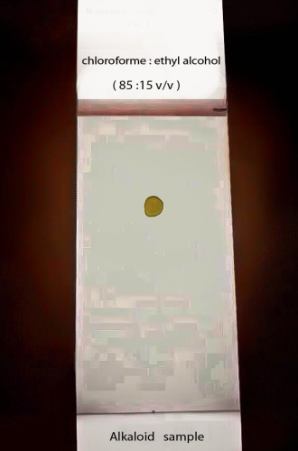
Fig. (3) Silica gel plate illustrate Rf value of active substance(alkaloid) isolated from Maghrabi banana extract.
Recrystallization from methanol followed by purification processes was carried out where pale yellow semi-powder with melting point 60̊ c. The purity as well as the unsaturated nature of the separated compound which gave positive reaction with characteristic test of Alkaloid.
The spectroscopic characteristics of the purified active alkaloid substance
The UV absorption spectrum of the active substance in methanol using Perkin – Elmer Lambeda 15 UV/V spectrophotometer, exhibit maximum absorption at 251 nm. Also the structure of alkaloid compound was confirmed by:
IR spectrum showed absorption bands at 3429 cm¯¹ for µ(OH and NH), at 2921 cm¯¹ for µ CH aliphatic, 1735 cm¯¹ for µCO and at 1633 cm¯¹ for µ C=Cwhich illustrated in fig.(4).
Mass spectrum (MS) showed molecular ion peak at m/z=283(1. 11) which corresponds to molecular formula C13H17NO6, which identical with the correct elemental analysis, Also M.s showed different fragments in fig. (5) Which confirmed the structure [fig. 6]of Fig. (7) and table (4).
Table (4). Showing the m/z followed by Relative abundance (%) of active substance(alkaloid).

m/z | 283  nm | 251  Nm | 209  nm | 220  Nm
Relative abundance (%) | 1. 11 | 2. 35 | 1. 36 | 0. 93

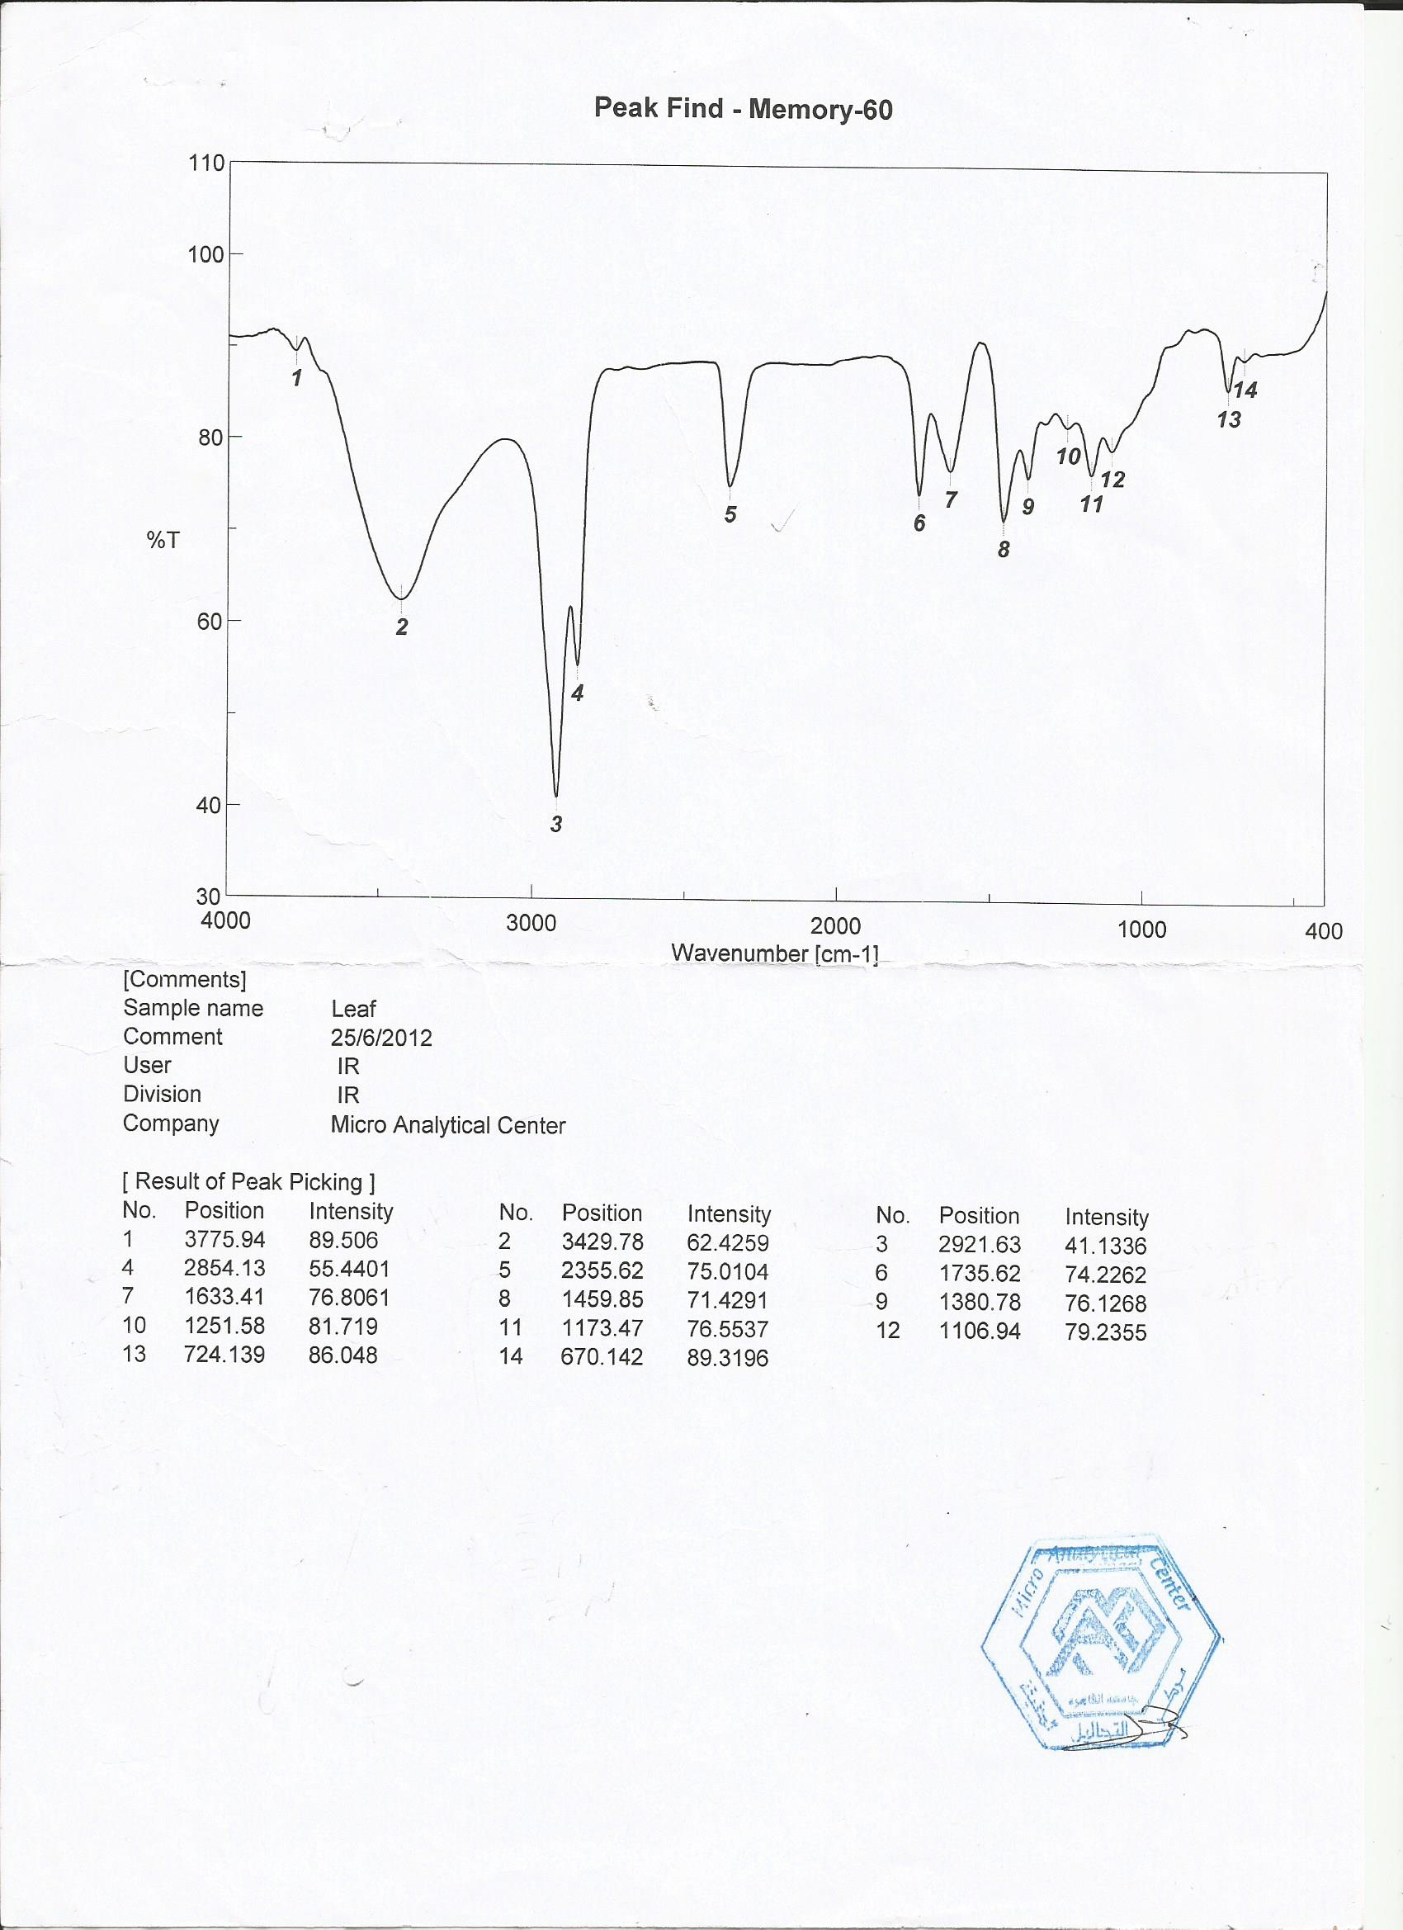
Fig. (4). IR spectrum bands of the purified active substance(alkaloid) isolated from banana waste cv. Maghrabi.

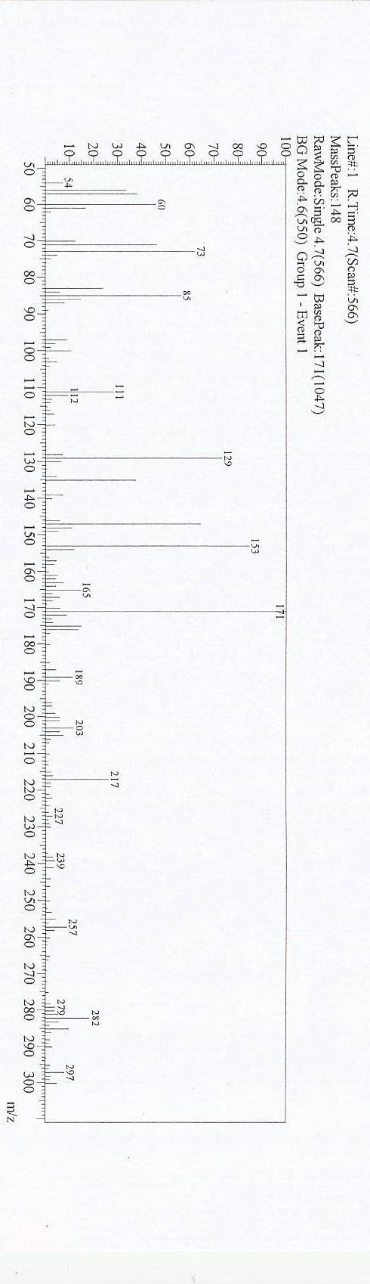
Fig.(5) Mass spectrum of the purified active substance (Alkaloid) isolated from banana cv. Maghrabi .

3. 1.2 -Identification of the purified active alkaloid compound.
According to the analysis of data obtained from spectroscopic characteristics chemical analysis and physicochemical properties of the active substance extracted from banana waste cv. Maghrabi, Figure (7).

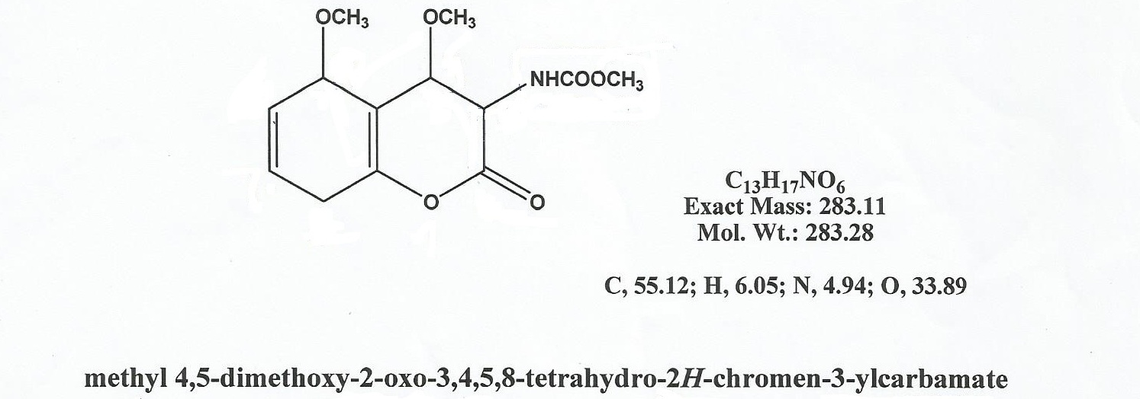
Fig. (6). The suggested chemical structure of purified isolated alkaloid.
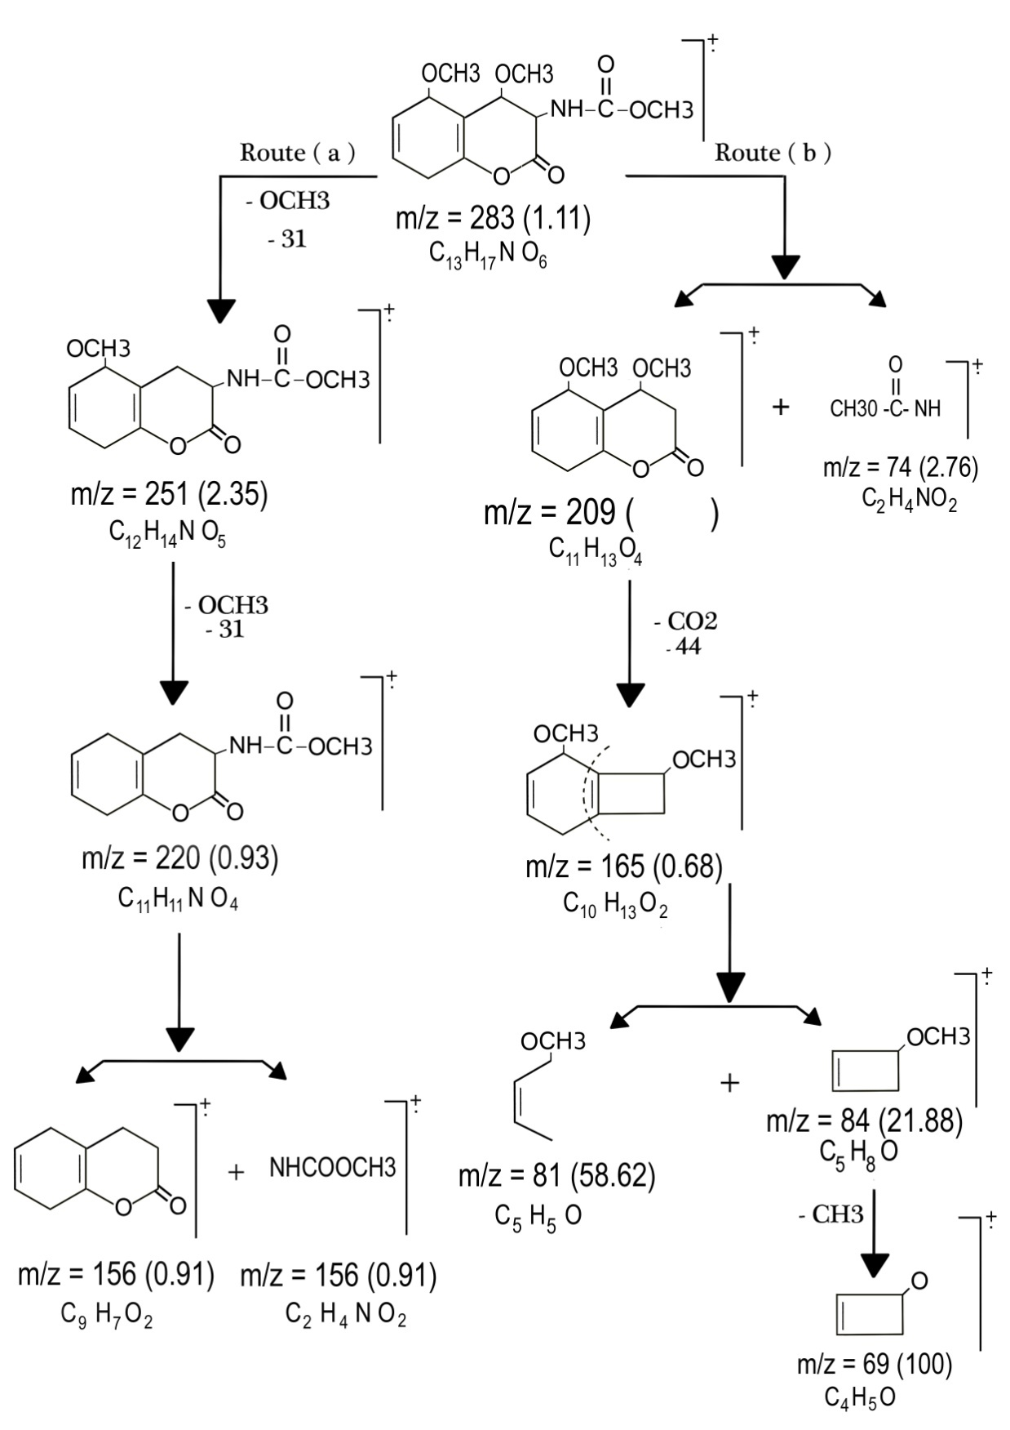
Fig. (7). The fragmentation of suggested structure of isolated alkaloid Compound.

The secondary metabolites in plants can be divied into different categories according to their biosynthetic principles . A simple classification includes 3 main groups Agostini-Costa et al.,(2012): (1) Terpenes such as mono- ,di- ,tri- ,sesqui- and tetraterpenes,saponins , steroids , cardiac glycosides and sterols (2) Phenolics such as phenolic acids , coumarins , lignans , stillbenes , flavonoids , tannins and lignins (3)Nitrogen containing compounds such as alkaloids and glucosinolates.
The presence of flavonoids and tannins to be responsible for the free radical scavenging effects observed . Flavonoids and tannins are phenolic compound where the plant phenolics are a major group of compounds that act as primary antioxidants or free radical scavengers. Steroids have been reported to have antibacterial properties Raquel (2007)and they are very important compounds especially due to their relationship with compounds such as sex hormones Okwu. (2001).Alkaloids have been associated with medicinal uses for centuries and one of their common biological properties is their cytotoxicity Nobori et al., (1994).

References
Ahmed, A. ;Khan, K.A.; Ahmad, V. U.; Qazi, S. (1986).Antibacterial acivity of Juliflorine isolated from Prosopis juliflora. Planta Med.4,285-288.
Aiello, A. ; Fattorusso, E. ; Imperatore, C. ; Irace, C. ;Luciano, P. ; Menna, M. ; Santamaria, R. ; Vitalone, R. and Zorrimidazolone (2011). A bioactive alkaloid from the non-indigenous Mediterranean stolidobranch Polyandrocarpa zorritensis. Mar. Drugs 9, 1157-1165.
Agstini-Costa, T.S.; Bizzo, H.R;Silveira, D and Gimenes, M.A. (2012).Secondary Metabolites.In: Chromatography and its applications . Dhanarasu DS (ed) In Tech Brazil.
Akpabio, U.D. ; Udiong, D.S. and Akpakpan, A.E.(2012).The physicochemical Characteristics of plantain (musa paradisiaca) and banana (Musa sapientum ) pseudostem wastes.Advances in Natural and Applied Sciences , 6(2) : 167 – 172.
Ayoola, P.B. (2011).Determination of proximate composition, vitamins, phytochemical and mineral contents of Musa paradisiacal (plantain) root. G.J.P &A SC and Tech., vol12 (16-29).
Das, K. ; Tiwari, R.K.S. and Shrivastava, D.K. (2010).Techniques for evaluation of medicinal plant products as antimicrobial agent: Current methods and future trends. Journal of Medicinal Plants Research; 4(2): 104-111.
Dina M.B. ;Mohamed N.SH.; Aly A.M.;Hazaa M.M and Heba S.E. (2014). phytochemical bioactive analysis of banana pseudostem cv. Maghrabi in Egypt.J.Biol.Chem. Environ. Sci., Vol. 9(2):57-68.
Frison, E. and Sharrock, S. (1999) .The economic, social and nutritional importance of banana in the world. In: Picq, C., Foure, E., Frison, E.A (Eds). Banana and Food Security International Symposium, Douala, Cameroon, 10-14 November, 1998.
Harbone, J. (1998). Phytochemical methods: a guide to modern techniques of plant analysis. Springer, Nature, 302 pages.
Henriques, A.T. ; Limberger, R.P. ; Kerber, V.A. and Moreno, P.R.H. (2004). Alcalóides: Generalidades e Aspectos Básicos. In Farmacognosia: Da Planta Ao Medicamento, 5th ed.; Simões, C.M.O., Schenkel, E.P., Gosmann, G., Mello, J.C.P., Mentz, L.A., Petrovick, P.R., Eds.; Editoras of the Universidades Federais de Santa Catarina and Rio Grande do Sul: Porto Alegre/Florianópolis, Brazil, Chapter 29, pp. 765-792.
Imam, M. Z. and Saleha, A. (2011). Musa paradisiaca L. and Musa sapientum L.: a phytochemical and pharmacological review. Journal of Applied Pharmaceutical Science; 1(5):14-20.
Ncube, N.S. ; Afolayan, A. J. and Okoh, A. I.(2008). Assessment techniques of antimicrobial properties of natural compounds of plant origin: current methods and future trends. African Journal of Biotechnology ; 7 (12): 1797-1806.
Nobori , T.K. ,Miurak ,D.J., Wu , L.A Takabayashik , and D.A Carson (1994). Deletion of cyclin-dependent kinase- 4 inhibitor gene in multiple human cancers.Natuer, 46:753-756.
Okwu , D.E. and Okwu , M. E. (2004 ). Chemical compostion of Spondias monbin linn . Plant parts . J. Sustain . Agric . Environ ., 6 (2) : 140-147.
Okwu , D.E. (2001). Evaluation of chemical composition of medicinal plants belonging to Euphorbiaceae .Pak Vet .J. 104:160-162.
Raquel, F.E. (2007).Bacterial lipid composition and antimicrobial efficacy of cationic steroid compounds . Biochemical et Biophysica Acta. 2500-2509.
Sofowora, A. ( 1993). Medicinal Plants And traditional Medicine InAfrica. Spectrum Books Ltd., Ibadan, Nigeria, pp. 191-289.
Yu, B. W. ; Chen, J. Y. and Wang, Y. P. ; Cheng, K. F.; Li, X. Y. and Qin, G. W.(2002). Phytochemistry, 61, 439.
الفحص الكمي للمركبات الفيتوكيميائية ذات النشاط الحيوى من مخلفات نبات الموز

*ريهام محمد مصطفي -** على عبد المعبود -* محمود هزاع -* هبة سامي عيسوى

* قسم النبات – كلية العلوم – جامعة بنها

** قسم الكيمياء -كلية العلوم – جامعة بنها
المخلفات النباتيه للموز لها تأثير دوائى كبير يستخدم فى المجال العلاجي لهذا استهدفت هذه الدراسة التعرف على المركبات الفعالة (نواتج الايض الثانوى ) لمخلفات الساق الكاذبة والاوراق لأربع اصناف من نباتات الموز الحلو (المغربى والوليامز )والنشوى (البراديكيا و السنارى) النامي فى بنها التابعة لمحافظة القليوبية من خلال القياس الكمى وذلك عن طريق اختيار وجود او غياب المركبات الفعالة . حيث اظهرت النتائج عن وجود القلويدات – والتانينات – والاستيرويدات – والتربينات – والصابونيتات – والفلافونويد فى الاصناف الاربعة بنسب والوان مختلفة وذلك لاختلاف المحتوى الكيميائى لكل صنف.
فقد تم فصل وتعريف مركب من الصنف المغربى غير مشبع يعطى صفات القلويدات ودرجة انصهاره 60° c وباستخدام التحليل امكن تحديد الصيغة الجزيئية له C13H17NO6,

